**PX330-based plasmids, + single guide RNA:**

(Edited based on Feng Zhang’s lab from MIT, Cornell University Transgenic Core CRISPR/Cas9 Genome editing)

**A. sgRNA design**

sgRNA (sg = short guide) directs the Cas9 nuclease to a cleavage site in the genome.

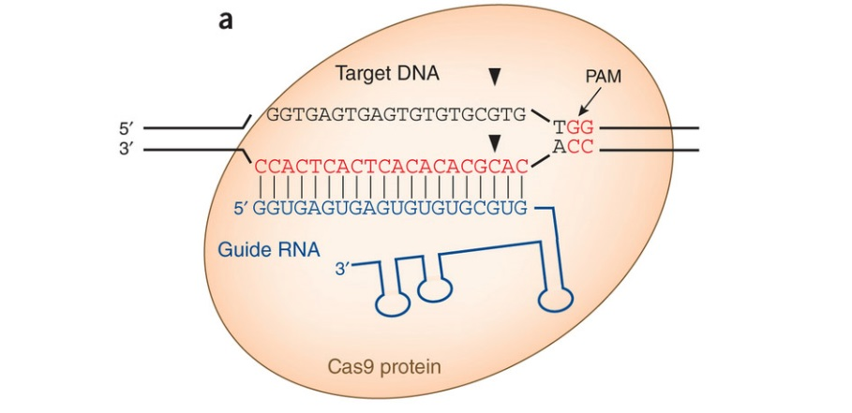

Figure 1. From Staying on target with CRISPR-Cas . Dana Carroll , Nature Biotechnology 31,807–809 (2013).

1. Use website <https://www.dna20.com/eCommerce/cas9/input>, put the interested gene name to get the higher score sgRNA, select the species, cas 9 taye( wt). Choose the top three target sequences on the 5’ end, and the top three for the 3’ end.

Such as axin 1, click √ to select “Search only in the first common exon”. <https://www.dna20.com/eCommerce/cas9/results>

1. the blue color marked oligo is our purpose sgRNA. CACCCCAAGACGTTCAGATC

AGCCACCCCAAGACGTTCAGATCTGGATC

▲

▼

TCGGTGGGGTTCTGCAAGTCTAGACCTAG



1. Design the primers

To clone the guide sequence into the sgRNA scaffold, synthesize two oligos of the form:

5’ – CACCGNNNNNNNNNNNNNNNNNNN – 3’

3’ – CNNNNNNNNNNNNNNNNNNNCAAA – 5’

To clone in your target sequence, synthesize two partially complementary oligos with 4nt overhangs compatible for cloning into the vector. "N" and "n" represent complementary base pairs. PAY CAREFUL ATTENTION TO THE 5' > 3' ORIENTATIONS

5’ –**CACC**GNNNNNNNNNNNNNNNNNNN –3’ 5’ -**AAAC**nnnnnnnnnnnnnnnnnnnC -3’

When annealed oligos form double stranded DNA with overhangs for cloning into *Bbs*I site in px330.

5’ –**CACC**GNNNNNNNNNNNNNNNNNNN – 3’

3’ –CNNNNNNNNNNNNNNNNNNN**CAAA** –5’

Forward primer: 5’ –**CACC**GNNNNNNNNNNNNNNNNNNN –3’

Reverse primer: 5’ -**AAAC**nnnnnnnnnnnnnnnnnnnC -3’

Note: 1) make sure The PAM site is not included in the sgRNA sequence.

2) Add CACCG to forward oligo(if there is G in the 5’ site, just add CACC).

3) Design the oligo 2, Get reverse complementary sequence of forward oligo, then add aaac to 5’, c to 3’ site.

**Design note for expressing sgRNA in cells from the U6 promoter** **in pX330**: Please note that for the pX330 cloning backbone, the example guide sequence one base ‘G’ followed by 19 Ns. Because it needs U6 promoter to have a ‘G’ base at the transcription start site. Hence, we recommend finding a 20bp genome target starting with the base ‘G’. If you have to use other bases at the starting position of your genome target, you could add an additional ‘G’ to the front of your target. If you are going to use the construct simply to make RNA for microinjection into mouse embryos, then you can ignore this issue.

**B. sgRNA cloning**

**Oligo annealing and cloning into backbone vectors:**

1. Set up digestion reaction:

X µl pX330 (1- 2 µg)

2 µl 10X NEBuffer 2.1

1 µl *Bbs*I (NEB) Use more if cutting more DNA

H2O to final Volume of 20 µl

Incubate the digestion reaction at 37oC for at least 1hr. Run ~200ng on agarose gel to ensure COMPLETE digestion. Heats inactivate (65°C for 20 min) and columns purify linearized plasmid.

If not complete, add more enzyme and 1X buffer and go longer. Re-run a gel to confirm digestion. When digest is complete, heat inactivate (65°C for 20 min) or column purify linearized plasmid.

Note:I tried 2 ug vector, and digested for 3-4 hours, the digestion is complete.

2. Gel purify digested plasmid using any kind of Gel Extraction Kit and elute in dd H2O.

But I didn’t run the gel and recycle it, only use the kit to extract the digestion product, not need to run the gel.

3. Phosphorylate and anneal each pair of oligos:

1 ul oligo 1 (100μM)

1 ul oligo 2 (100μM)

1 ul 10X T4 Ligation Buffer (NEB)

6.5 ul ddH2O

0.5 ul T4 PNK (NEB)

10 ul total

Anneal in a thermocycler using the following parameters:

37oC 30 min

95oC5 min and then ramp down to 25oC at 5oC/min

Note: 1) the oligo dilution is similar to PCR primer dilution.

1. after anneal the oligo, the dilution is around 200, and check the concentration with nano drop, the

concentration is around 50-100 ng/ul.

4. Set up ligation reaction and incubate at room temperature for 10 min:

X ul *Bbs*I digested plasmid

from **step 2** (50ng)

1 ul phosphorylated and annealed

oligo duplex from **step 3** (1:150--1:200 dilution)

5 ul 2X Quickligation Buffer (NEB)

X ul ddH2O

10 ul subtotal

1 ul Quick Ligase (NEB)

11 ul total

Or the ligation system as following (I use T4 ligase kit from neb or other t4 ligase kit, such as thermos fisher):

X µl pX330 BbsI digested vector (50ng)

2 µl annealed oligo duplex from step 1 (1:250 dilution)

2 µl 10x DNA ligase buffer (make sure fresh, else ATP or DTT may be shot)

1 µl T4 ligase

Y µl H2O to 20 µl final volume

- Incubate the ligation reaction according to manufacturer recommendations.

(NOTE: many protocols call for phosphatasing the oligonucleotides. This won't hurt, but it doesn't matter since the vector ends are phosphorylated. Also, some people gel purify the plasmid after digestion. It can't hurt, but if your digest went to completion, this is a waste of time. Essentially, this procedure is "forced" cloning, since the sites in the plasmid are incompatible and the annealed oligos can only clone in the correct orientation and the plasmid cannot recircularize.

5. Transformation with 1 - 2 ul of the final product into competent cells

6. Pick colony and sequence verify with U6 sequencing primer (U6seqF:ACTATCATATGCTTACCGTAAC), I usually pick up 3 clones for sequence.

**Note :**

**1.** sgRNA must match a 20 nt target sequence (protospacer sequence) in the genomic DNA and must be followed by a protospacer adjacent motif (PAM) sequence of NGG (see Figs. 1,2). This NGG motif is essential for DNA cleavage. The PAM site is not included in the sgRNA sequence. The 12nt preceding the PAM is called the "seed" sequence; it is necessary for efficient cleavage. A perfect match between your seed sequence and non-target loci should be avoided when designing sgRNAs. Mismatches close to PAM site usually abolish DNA cleavage.

**2.Useful sites for sgRNA design and off-target testing**

• <http://www.genome-engineering.org/crispr/?page_id=41>

• <http://www.addgene.org/CRISPR/guide/>

• <http://crispr.mit.edu/>